.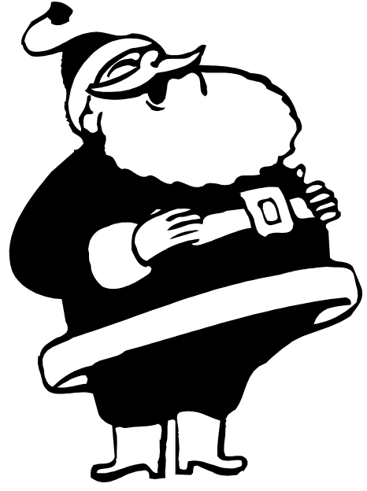non-compete Claus
I don’t deliver Easter eggs!

